Logbook Windows
Created with the Personal Edition of HelpNDoc: Full-featured EPub generator

Logbook Entry Window

Geoff Anderson G3NPA, Jim Hargrave W5IFP and Aki Yoshida JA1NLX

1.0 BASIC SETUP

As the name implies, this is the window through which the main entries are made to the logbook. It is quite complex and highly configurable so you are well advised to take time to study this section to fully understand what facilities are available from here. The picture shown below is the most basic Logbook Entry Window.

The top line shows the Frequency, Mode and Band that will be logged. The Frequency will be derived from your radio if you have CAT control and it is set up and activated. If you do not have computer control, then the frequency can be set manually. The Mode and Band will be derived from your Bandplan or, if desired, they also can be set manually. Below the top line are edit boxes for Callsign, RST Sent, RST Received, Name and QTH. You MUST enter a callsign at the very least before you can transfer anything to the log.

To change between edit boxes use the <TAB> key on the keyboard. Conversely the <Up Arrow> key will act as a Back-Tab <Shift+TAB> key combination. To transfer the QSO information to the logbook, use the key combination <Ctrl+L>_or the <Enter> key. If you wish to clear the whole entry window for any reason, use the <F11> key (if the focus is in the Logbook Entry window), the key combinations <Ctr-C>_or <Alt+W> or a left-click on the left side of the Logbook Entry window about 1/4 inch to the left of the entry fields. As a rule of thumb - click over Call, Sent, Rcvd, Name, Cmnt/QTH/Addr or bottom left user field caption.

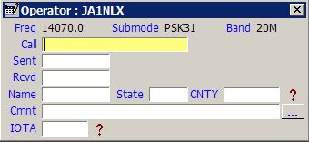

LBEW_1

As soon as you enter a callsign prefix that is recognized, the following will occur:

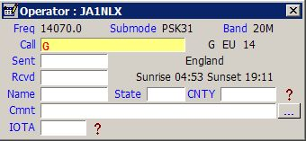

LBEW_2

Note: that the Country name, Sunrise and Sunset times, Short and Long Path beam headings and the Short Path distance are all calculated and displayed. If it should happen that you have many edit boxes visible, then some or all of this latter information may not be visible here. However, the same information is displayed on the Upper Status Bar at the bottom of the main window, so the information is still available.

Continuing with the Callsign entry, once you have typed sufficient information AND there are matching callsigns already in your log, Logger32 will display those callsigns (Callsign Preview). If the one you require is in the list presented, then selecting that callsign will place it in the Call edit box of the Logbook Entry window. If not, just continue to type in the remaining letters. See the example below:

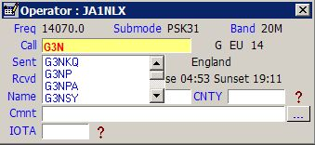

LBEW_3

If you do not see this type of presentation, then right-click in the Callsign edit box, select the" Setup" menu item from the pop-up menu and check "Show callsign preview" menu item from the menu list displayed.

Right-click in any edit box to show menu. Many examples are described later.

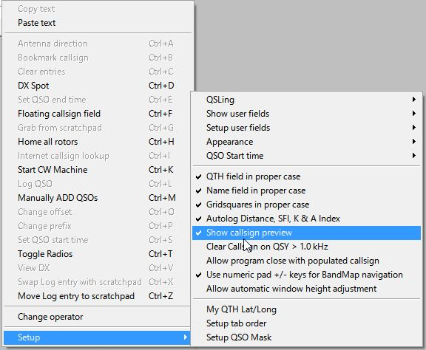

LBEW_3A

Note: It is preferred that you enter a callsign in the format: Callsign / Prefix modifier. For example W4xxx/1 (a W4 portable in area 1) or G3xxx/FR/T (A G prefix operating on Tromelin Island).

Logger32 will accept a number of different callsign formats BUT occasionally, especially where the prefix modifier is complex (like FR\T or KH0\M), the determined location, Zone etc., can be incorrect if other formats are used.

Logger32 has, in fact, seven more edit boxes that you can configure for use. To do this, right-click on any of the visible edit boxes to produce a pop-up menu. Select the Setup | Show user fields | Show all user fields menu items. This will activate all the user-definable edit boxes. If you only require one or a special combination of panes, then these may be selected using the Show User field # menu items.

Note: If the additional User FIelds have been configured, then the assigned Field Name will be displayed in the menu items in place of the Field #.

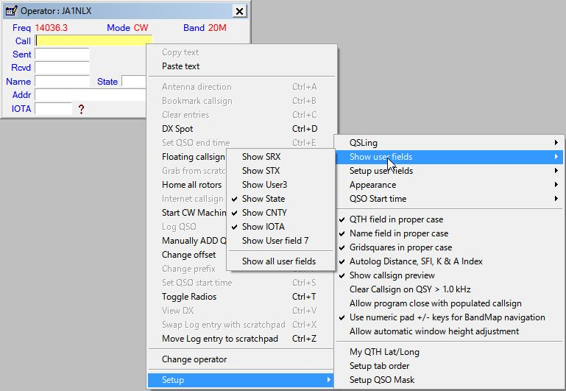

LBEW_4

Note: Auto-logging of Distance does not require an internet connection. However, auto-logging of SFI, A_Index, and K_Index only occurs after at least one instance of a WWV or WCY report has been received via a connection to a DX Cluster node -- whether automatically originated by the node or from an SH/WWV or SH/WCY command sent to the cluster.

Logger32 will use the most recent SFI A and K numbers received until Logger32 has been closed -- even after the your connection to the Cluster drops or is deliberately disconnected.

With all edit boxes visible the Logbook Entry window will look like this:

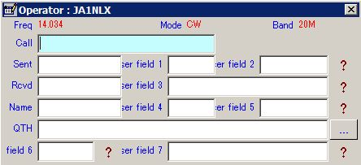

LBEW_7

Take note of the location of the seven user edit boxes and their numbering. Each one of these boxes can be set up to accept ANY ADIF type entry. Right-click on any of the edit boxes, select the "Setup | Setup user fields" menu items and pick the field of your choice. In the example below, USER 5 was selected.

Enter the label required, select the ADIF field type and in this case the <Show Help> button. Make other selections to suit. Be aware that the list of ADIF fields available from the pull-down list will change. Once one of the ADIF definitions has been used the same definition will NOT appear in the list again thus preventing its use in a second edit box. To restore the definition to the list you must remove it from the edit box that is using it.

For further information on the use of the "CW Machine Free field" option in the lower section of the setup window below, please see the CW Machine Window topic.

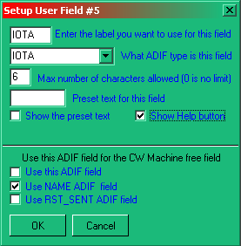

LBEW_8

The settings above for User 5 are shown below. The "?" mark is the Help button and a selecting this will reveal information about your IOTA contacts.

  - A LEFT-click will show information about the Island Group; and,

  - A RIGHT-click will open a generic window showing contacts with the IOTA Island.

Note: The RIGHT-click feature also applies to the STATE and CNTY fields

Note: Only fields 2,3,5,6 and 7 can have a "?" Help button associated with them.

It is possible to edit boxes to display Upper Case only provided that the field definition is one of the USER # ADIF fields. The option to do this will ONLY appear if the ADIF field of USER 1,2 or 3 is being used.

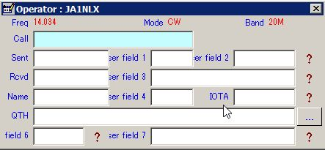

LBEW_9

If you wish to limit the number of characters that can be entered into a field or have something preset in a field, then complete the appropriate parts in the setup window for that field.

Shown below is an example for the Logbook Entry window.

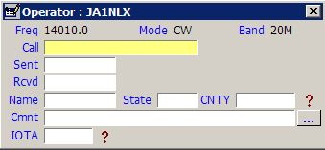

LBEW_10

Note: The button next to Cmnt field will cause the fields on this line to toggle between Comment, QTH and Address.
A new feature has been added whereby you can now add preset text to the Comment field. See the menu item "Setup user fields".

Selecting the "Setup Comments" menu item will display the Setup Comments field dialog box.

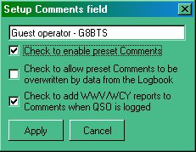

LBEW_12

Here you have the option to set a comment you may wish to add to the Comments column. Note that there are three selectable options:

  - If you want the phrase to appear, then you must check the "Check to enable" box;
  - If you would like to add the WWV/WCY reports received from a cluster, then check the bottom check box.
For example: with both of the above options selected, the Comments field in the log will fill as shown.

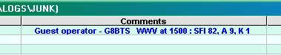

LBEW_13

  - If you want comments for a specific callsign already in the log to override the this comment, then click the middle check box. This assumes of course that you have selected to copy over the comments from the previous QSO using the QSO mask.

There is a potential for conflict with this option however. If the user has Comments checked in the QSO Mask, each successive QSO will append the WWV/WCY report for each QSO. The error message shown below will be generated if this conflict exists.

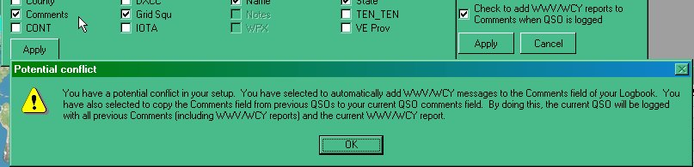

LBEW_14

In addition to that above, an automated feature has been introduced to record the A and K indices, the SFI and the distance to the QSO partner (in Km). Right-click on the Logbook Entry window and select the Setup | Autolog Distance SFI K and A Index menu items.

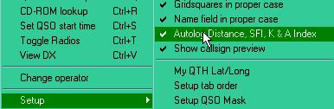

LBEW_15

With this option checked, QSOs are automatically logged with data from the WWV/WCY and Distance panels on the Lower Status bar.

Notes:

  - It is not necessary to have SFI, DISTANCE A and/or K_INDEX user fields on the Logbook Entry Window;
  - It is not necessary to have SFI, DISTANCE A and/or K_INDEX user fields visible on the Logbook Entry Window;
  - If the user has entered SFI, DISTANCE A and/or K_INDEX into user fields on the Logbook Entry Window, the field(s) will not be overwritten; and
  - If there is no data in the right side of the Lower Status bar from WWV or WCY, then nothing will be written to the SFI and/or A/K_INDEX fields.

2.0 QUICK QSY

Logger32 has the ability to accept an input frequency in the "Call" edit box of the Logbook Entry window. This input frequency must be in the format of the frequency recorded in the log. In the "Call" edit box, simply enter the frequency and press <Enter>. If you have a radio with a CAT interface, it will QSY to the frequency you have just entered.

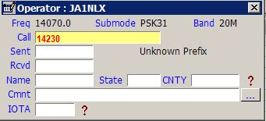

LBEW_16

In the example above, the <TAB> or <Enter> key has not been pressed. As soon as one of them is, the "Call" edit box will clear and the radio will go to the entered frequency.

The current Received frequency can also be changed by using the scroll wheel on the mouse. Place the cursor anywhere in the Logbook Entry window and rotate the scroll wheel. One direction will increase the frequency while a rotation in the other direction will decrease the frequency. The step size for each scroll wheel click can be selected from a menu item list by right-clicking on the actual frequency displayed alongside the word "Freq". Depending on the polling interval of your computer/transceiver interface, the speed of the frequency change may be somewhat slow. The change may not be immediate as if you were turning the radio's tuning knob.

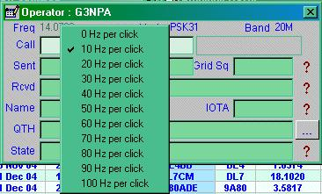

LBEW_17

3.0 OTHER SETUP MENU ITEMS

To access menu items right-click in any edit box and select Setup menu item.

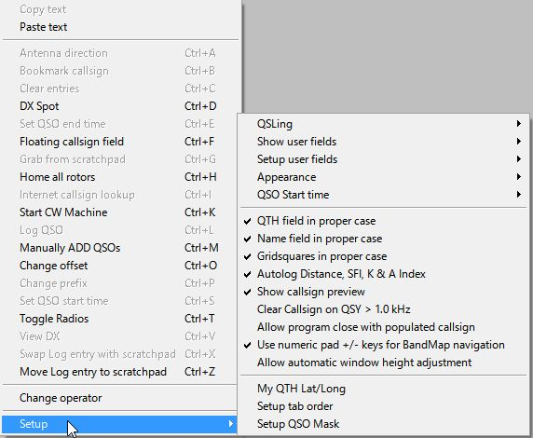

LBEW_17A

3.1 Appearance

To access menu items right-click in any edit box and select Setup menu item.

LBEW_17A

The general appearance of the Logbook Entry window can be adjusted to suit individual tastes.You can change a whole range of items such as Background, Highlight and Font colors as required - for both the Data and the Field names.

3.2 Entry Window Tab Order

Following the entry of a Callsign, you can arrange to <Tab> through the Logbook Entry window in any order you wish.

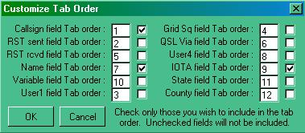

LBEW_18

In the left-hand edit box, enter the order number for each field to fall and if you require that field to be included in the tab sequence, place a check mark in the check box. In the example above only three fields have been selected in the order Callsign, Name and User 5 (which you have defined as the IOTA number). Having completed your selection, select the <OK> button.

Note that your bandplan can set the default RST sent (normally 599) and the RST received field will default to 599 if nothing is entered. In the above case, Having entered a callsign, a single <Tab> will take you to "Name" having filled in the two reports of 599 on its way.

3.3 QSO Mask

Logger32 has the ability to look at your logbook and extract information from the last QSO you had with someone and display this in the Logbook Entry window. For example, if you had worked Bob K4CY previously and you had correctly recorded his name in the Name field, then the next time you enter his callsign, this information can be retrieved and put in the Logbook Entry window automatically. Select those items that you wish to be carried forward. In the example below, Name, QSL Via, QTH and State will all be transferred from the previous contact record to the new one. Now you know how Bob is so quick on coming back with your name if you work him twice!

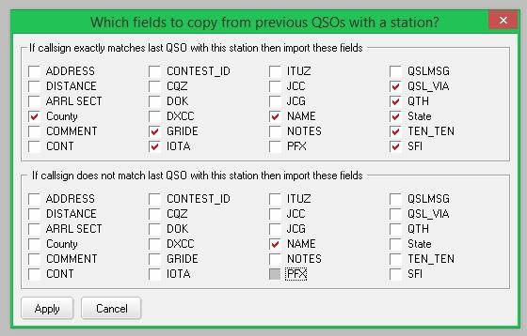

LBEW_19

3.4 GridSquares in Proper Case

If this option is checked, then captured or directly input information will appear in the form "IO82nd". If unchecked, the format will remain as typed (or captured).

3.5 Name Field in Proper Case

If this option is checked, then captured or directly input, information will have the first letter of the name capitalized and the remainder in lower case, i.e., Geoff. If unchecked, the format will remain as typed (or captured).

3.6 QTH Field in Proper Case

If this option is checked, then captured or directly input information will have the initial letter of the name capitalized and the remainder in lower case, i.e., London. If umchecked, the format will remain as typed (or captured).

3.7 QSO Start time

A QSO is transferred from the Logbook Entry window into the logbook following an <Enter> key or <Ctrl+L> key combination. This action also automatically sets the QSO end time. Two options to automatically set the Start Time are available:

3.7.1 When Callsign Field Loses Focus

If this option is selected, the QSO Start Time will be taken to be the moment you enter the <TAB> key to move away from the Call edit box to add further information into the Logbook Entry window. The <Ctrl+S> key combination will override the Start Time even if it is used before the first time the callsign field loses focus

3.7.2 When QSO Entered into Log

If this option is selected, then the Start Time will be the same as the End Time. Even with this option selected the <Ctrl+S> key combination will still record the Start Time if pressed.

Note: Both the Start and End times can be recorded automatically if the $starttime$ and $endtime$ MACROs are used in the shortcut key definitions in the MMTTY and MMVari windows. These macros are NOT available for use in the CW Machine.

3.8 Clear Callsign On QSY

With this option selected, a callsign in the Call edit box will be cleared when tuning the receiver away from the current frequency by more than +/- 1KHz. You can set the QSY frequency threshold to something other than the default 1KHz by adding the following to the [Globals] section of the Logger32.INI file.

[Globals]
...
Allowable QSY Frequency=2.4 (or 2.5 or whatever in KHz).

The QRZ and other lookup windows are closed when the Call edit box cleared following a QSY.

3.9 Allow program close with populated callsign

If this option is checked then it allows Logger32 to be closed without clearing the Logbook Entry window.

3.10 Use numeric pad +/- keys for BandMap navigation

If this option is checked then it will allow to navigate through DX Spots on the BandMap

3.11 Allow automatic window height adjustment

If User field 6 and 7 are not visible and this option is not checked then you see like this.

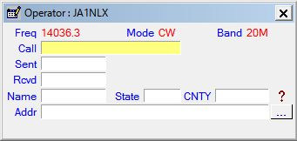

LBEW_19A

If User field 6 and 7 are not visible and this option is not checked then you see like this.

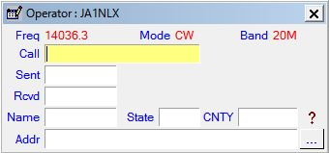

LBEW_19B

4.0 OTHER MENU ITEMS

  - <Ctrl+F> will open the Floating Callsign form;
  - <Ctrl+K> will open the CW Machine with focus in the Logbook Entry window.
  - <Ctrl+X> swaps the selected Scratchpad record with the Log entry.
  - <Ctrl+Z> will open the Scratchpad (if not already open) and toggle the Log entry to the Scratchpad.
  - Change operator: The Logger32 logbook is designed to be used by one or more operators. If you wish to change the operator who is using the log at the time, select this option and change the callsign.
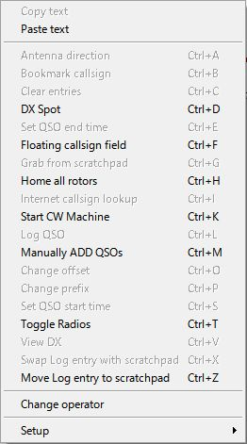

LBEW_20

4.1 Note For Control + Letter Functions

You will see from the above menu that there are a number of functions that can be accessed using shortcut keys. All are reasonably self-explanatory, except perhaps the one that is grayed out in the above example. Antenna direction is gray because in this case the antenna rotator function is not set up and/or the COM port is not activated. The "Change Offset " will only show in black typeface if a prefix for a country with several time zones is entered (USA, Russia, etc.) and the station being worked is not in their own area. For example, enter the prefix W1 and note that this shows time and distance based on the station being in Concorde, NH. If this station was actually in California, the time and other information shown would be incorrect, so press the <Ctrl+O> key combination and a small window will appear allowing you to highlight the appropriate area - in this case W6. Right-click on W6 and then the <Select> button. The calculated times, distances, etc., will now be based on San Francisco.

The <Ctrl+T>, <Ctrl+A> keystroke combinations may be intercepted globally depending on the options set in the Radio Configuration and Rotator Setup windows. Other Ctrl codes need the focus to be in the Logbook Entry window before they become effective.

The <Ctrl+D> key combination will allow you to forward a DX spot to a DX cluster. If the Logger32 Main menu option Setup | DX Spots | Prompt for Comments menu items are selected, then you will see the following dialog box.

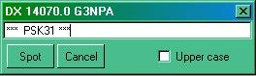

LBEW_21

All of the report to the cluster is preformed, the header showing the frequency and callsign of the spot. Anything typed into the edit box will appear as a comment. Click on the <Spot> button to send.

You must be connected to a cluster before this facility will work. The appropriate Cluster port and frequency format is selected from the Logger32 Setup Menu | DX Spots menu item.

A DX spot report is normally based on the callsign currently entered in the Logbook Entry window. However, if no callsign is entered, then Logger32 will assume that you wish to send a spot for the last entered callsign that is recognized in the log.

5.0 Band Mode Selection Setup

If you right or left-click on any of the titles Frequency, Band or Mode in the Logbook Entry window you can do several things.

5.1 Manual Entry

If you have no computer interface or you wish to manually enter details of Frequency, Band, Mode and/or Sub Mode, remove the check marks from Band from BandPlan and Mode from BandPlan (or Mode from Radio). You will now have complete manual control over what appears in the Logbook Entry window. Enter the details required and select the <OK> button.

The "Current frequency format is;" is dependent on your frequency resolution settings from the Logger32 Setup menu.

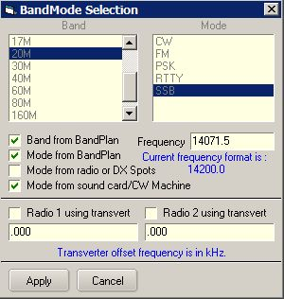

LBEW_22

5.2 Automatic Entry

If you wish to automate some or all of these functions and you have a computer interface to your radio, then place check marks in "Band from BandPlan" and "Mode from BandPlan" or "Mode from Radio" to suit your needs.

5.2.1 The Band from Bandplan

The "Band" details as recorded in the log will be determined from the information contained in the Band Mode table. If the table is set up correctly, a frequency of, for example, 14.070 MHz will give a band of 20M.

5.2.2 Mode from Bandplan

The operational Mode as recorded in your log will be determined from the information contained in the BandMode table. For example, a frequency of 14.070 MHz might show an operational mode of PSK. Note: The actual mode of the radio can be different and in this case could well be set to USB.

In the above two cases, the Mode and/or Band will change automatically as you tune through the bands.

5.2.3 Mode from Radio or DX Spots

If "Mode from Radio or DX Spots" is checked and you are using a CAT interface, then the mode displayed in the Logbook Entry window will be the mode of the radio (and not necessarily the actual mode of operation).

Note: This option better supports the mode sent in the comments field by DX Skimmer nodes such as on the Reverse Beacon Network. Reverse beacon DX Spots with mode in the comments field will decode want/need/worked/confirmed information based on that mode and not the Bandplan mode. As an example of how this would work. Say for example you have your Bandplan setup with 20M CW from 14000 to 14350 and RTTY from 14080 to 14100. A DX Spot on 14080.1 is assumed to be RTTY and want/need/worked/confirmed calculations are based on the mode being RTTY. Reverse Beacon clusters that aggregate DX Spots are now adding the mode to the comments field. So, the same DX Spot from a Reverse Beacon may have the frequency as 14080.1 but the comments field showing the mode as CW. In this case the new code will calculate want/need/worked/confirmed based on the mode being CW.

An additional benefit of knowing the actual mode rather than relying on the often inaccurate Bandplan, is setting the radio to the correct mode when clicking on the DX Spot. Again, using the same example of a DX Spot on 14080.1. If the user is configured to set the operating mode from the radio, clicking the DX Spot would set the radio to RTTY (or whatever the radio mode is to operate RTTY - maybe FSK) and set the operating mode to RTTY. Clicking on the same spot from a Reverse Beacon with mode in the comments field would switch the radio to CW (or whatever the radio mode is for CW - maybe CW-R) and set the operating mode to CW.

5.2.4 Mode from Sound Card/CW Machine

If the "Mode from Sound card/CW Machine" is checked then the "in use" mode of the soundcard (when open) will substitute the mode as derived from the Bandplan. This allows for a digital contester to operate anywhere in the band and the mode entered into the log will be dependant on the soundcard mode in use.

See the Logbook Page Window for typical examples.

6.0 PHONE/DIGITAL MODE SETUP

If you like to operate on digital and/or phone modes, there are further options available.

First there is the option of setting which modes get collectively summed for awards under the general "digital" and/or "phone" banners.

There is also the option of selecting what mode you want recorded in the logbook if you have selected the "Mode from Radio" option described above.

To set any of these, from the Logger32 Main menu, select the "Tools | Database Maintenance | Setup Phone/Digital Digital Modes" menu items to display the following dialog box.

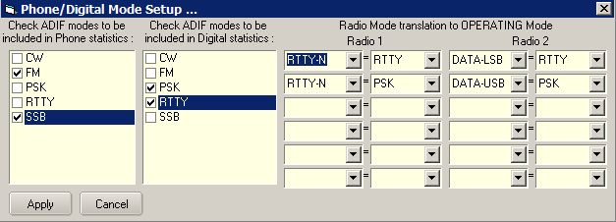

LBEW_23

The grouping of the modes is achieved by simply checking the desired modes in one or both of the two left-hand lists. Note that the order and content of these lists are dependent on the BandMode Table. If a mode you wish to include does not appear here, then it is not in your BandMode table, and it needs to be.

The right-hand side of this table is associated with the "Mode from Radio" option. Here you can effectively translate the actual radio mode selected to the mode name desired for logging. If you like to use the radio mode of DATA-USB for your PSK31 contacts, or you only operate SSTV via an SSB mode, then this is the place to select what you desire. Radio mode on the left; Logged mode on the right.

7.0 LoTW/OQRS USER INDICATOR

Provided that the user has already downloaded the LoTW User file and generated a LotWUser32 database, the Logbook Entry window will show a check mark if the callsign entered (either manually or from clicking on a DX spot) is found in that database.
Tooltips is displayed when mouse is moved over the check mark. Tooltips is displayed depending on your setting. If LoTW user file from Club Log is downloaded then it shows both LoTW user info and OQRS user info, or either info. Details are described in the DX Spot Window section.

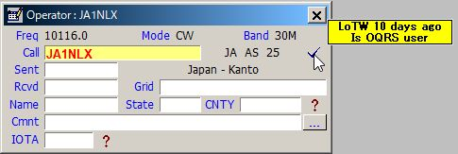

New LBEW_24

Information for uploading of the necessary LotW user data is given in the DX Spot WIndow topic.

Note: This check mark can also be setup to indicate that the callsign entered is a user of other lists. eQSL, etc. See Load LotW User File in the DX Spot Window topic for instructions on loading other lists.

8.0 Split Operation

When split operation has been initiated by clicking on a DX Spot with the qualifying Split syntax in the comments, the Logbook Entry window will display the dialog box shown below. Clicking on the SPLIT OPERATION indicator will cancel Split operation.

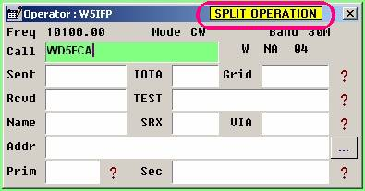

LBEW_25

To enable the visual indication, see the Radio Control Panel topic.

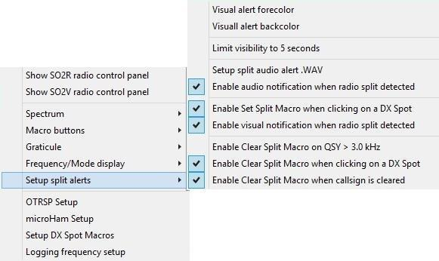

LBEW_26

9.0 SCRATCHPAD

9.1. General

Scratchpad is a tool to save interesting QSO information, just like making notes on paper. It also provides a function to copy the saved information into the Logbook Entry window or swap it between the Scratchpad and Logbook Entry window.

9.2. Setup

If you want to use the Scratchpad then you need to configure it first.

Press the <Ctrl+Z> key compbination to display the Scratchpad window:

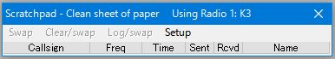

LBEW_27

Select the Setup menu item to display the Setup drop-down menu items:

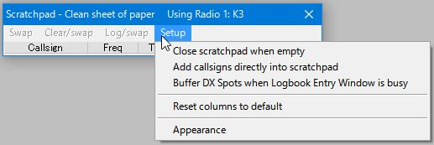

LBEW_28

If you want to enter the callsign (with other data) directly into the Scratchpad then you must select the option "Add callsigns directly into scratchpad".

If you want to save DX spots then you must select the option "Buffer DX Spots when Logbook Entry Window is busy".

Select the Appearance menu item to change the appearance of the Scratchpad. This is the default Setup table.

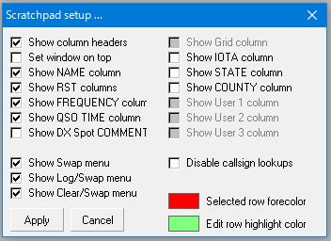

LBEW_29

You can display only the columns you need. You may also change the Selected Row forecolor and Row highlight color. Click the <Apply> button to finish the setup. See section 9.6 Tips for more setup tips

The following is an example of my setting and Scratchpad appearance. I recommend that the Set window on top option be checked.

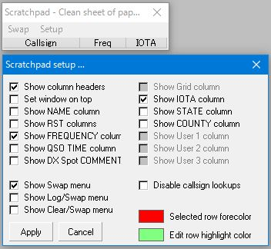

LBEW_30

9.3. Writing a QSO into Scratchpad

There are various ways to enter information into the Scratchpad.

9.3.1. Writing Information Directly into Scratchpad

You can enter information directly into the Scratchpad. You can add information with callsign and other fields except Freq, QSO time and DX Spot comments directly into the Scratchpad.

Type a callsign, e.g. Test1 in the callsign edit box. If you want to enter other columns, e.g. IOTA, then select the <TAB> key to move the focus. Type IOTA reference number and Select hit the <Enter> key to finish. The frequency displayed in Logbook Entry window will be entered in the Freq edit box.
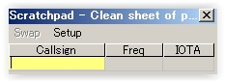

LBEW_31

Enter a callsign, e.g. Test1 in the callsign edit box. If you want to enter other columns, e.g. IOTA, then select an arrow key or the <TAB> key. Select the <Enter> key to finish. The frequency displayed in Logbook Entry window will be entered in the Freq edit box.

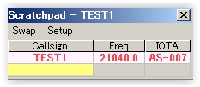

LBEW_32

If you want to enter information for another QSO, e.g. Test2 then type callsign in the box with yellow backcolor and select the <Enter> key.

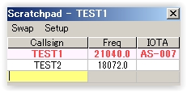

LBEW_33

9.3.2. Enter QSO Information When You Click on a DX Spot

You can save information of a DX spot QSO when the Logbook Entry window is busy. Simply click any DX spot in the DX Spots window or BandMap. The Callsign, Frequency and Comment info (Split and/or Mode) are saved.

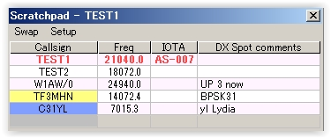

LBEW_34

Note: Callsigns are highlighted with same color as in DX Spots Window and BandMap.

9.3.3 Writing a QSO in Logbook Entry window

The current QSO in the Logbook Entry window is saved into the Scratchpad by using the (Ctrl+Z) key combination.

9.4. Transferring a QSO Into the Logbook Entry Window

There are various ways to transfer a QSO into the Logbook Entry window or to swap QSOs between the Scratchpad and Logbook Entry window.

9.4.1 Selecting a QSO in Scratchpad

Click the QSO you want to transfer/swap. The QSO will be highlighted with the configured color. (see 9.2 Setup) If the Logbook Entry window is empty then this QSO is copied into Logbook Entry window.

9.4.2 With the Focus in the Logbook Entry Window You Have Following Choices:

    - <Ctrl+X>: This is same as Swap below; and,
    - <Ctrl+G>: This is same as Log/Swap below

9.4.3 With the Focus in the Scratchpad You Have Following Choices:

    - <Ctrl+S>: This is the same as Swap below;

    - Selecting menu items if the item is displayed in menu bar;

    - Swap: Swap the QSO between the selected QSO in Scratchpad and Logbook Entry window;
    - Clear/Swap: Clear the current QSO in Logbook Entry window and copy the selected QSO from the Scratchpad into Logbook Entry window;

    - Log/Swap: Log the current QSO in the Logbook Entry window and copy the selected QSO from Scratchpad into the Logbook Entry window; and,

    - Right click on the QSO and select one of following items:
      - Swap callsign xxx: This is the same as Swap above;
      - Clear & Swap callsign xxx: This is the same as Clear/Swap above; and,
      - Log & Swap callsign xxx:This is the same as Log/Swap above.

9.5. Editing QSOs in Scratchpad

Note: More options are checked in the setup table for following examples.

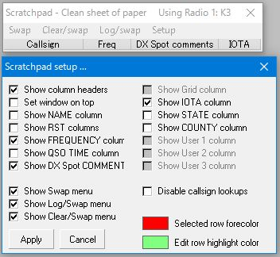

LBEW_34A

You can edit any QSO data except Freq, QSO time and DX spot comment. Right click the edit box you want to edit. In this case I want to edit IOTA with TEST2 QSO.

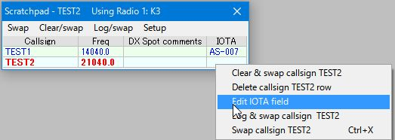

LBEW_35

Click Edit IOTA field and enter as-007.

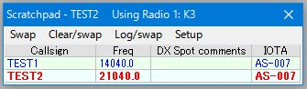

LBEW_36

If you want to edit other fields, e.g. Test2 then select to that field (TEST2).

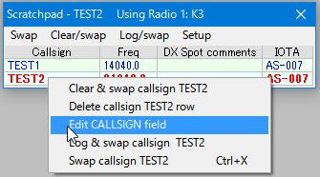

LBEW_36A

Click Edit CALLSIGN field and type TEST3. Hit the <Enter> key.

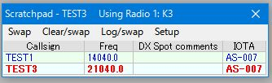

LBEW_37

9.6. Tips

9.6.1 QSO Time

This is the elapsed time after the Callsign field loses focus in Logbook Entry window. If you want to use this function then you must check "Callsign field loses focus" in the pull down menu.

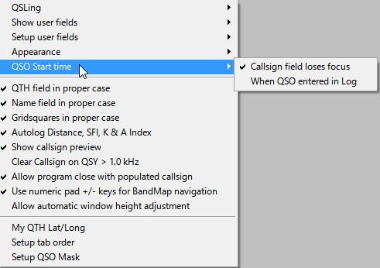

LBEW_39

9.6.2 When You Close Logger32

You may receive the following warning message. You must close the Scratchpad first then close Logger32.

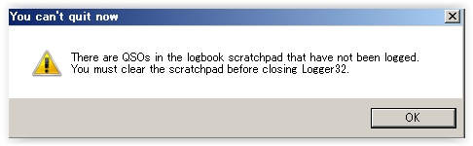

LBEW_40

9.6.3 Grid Appearance

To change the column order and width of the grids:

  - Drag the mouse on the border between columns to change column width; and,

  - Drag the mouse on a column to another column to change the order.

To change the text position displayed in each column, right-click the column header and select your desired option.

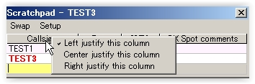

LBEW_41

9.6.4 Manual Entry Field Background Color in Scratchpad

This is the same as the Data field background and Data field background (focus) in the Logbook Entry window. In my case White for Data field background and Yellow for Data field background. The manual entry field background color is like this.

Manual entry field (Callsign);

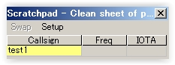

LBEW_42

Moving focus to IOTA field; and,

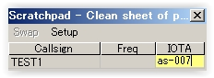

LBEW_43

When Scratchpad loses focus.

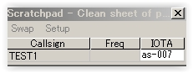

LBEW_44

10.0 FLOATING CALLSIGN FORM

Logger32 ver 3.49.229 and later has a Floating Callsign form. This form will display the current callsign that is posted in the Logbook Entry window "CALL" edit box. This window can be positioned anywhere on the screen(s) for handy reference for the current callsign being worked or checked for propagation. It can be positioned near the top of the Sound Card Data window or CW Machine window for quick reference. It is especially useful for users with 2 monitors.

To open the Floating Callsign form, place the focus in the Logbook Entry Window and enter the <Ctrl+F> key combination. You can also activate the Floating Callsign form with a right-click and select "Floating callsign field".

The following is a sample Floating Callsign form placed at the top of the screen just below the "Logger32" Title on the main MDI Form.

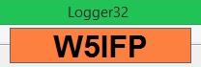

LBEW_45

Note: The Floating Callsign window will be blank if there are no entries in the Logbook Entry CALL field.
The Floating Callsign window can be configured to the user's preference. A right-click on the window will bring up the configuration menus.

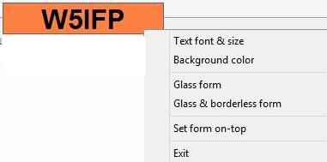

LBEW_46

  - Text font & size: You can select "Text font and size". Vertical size of the form is adjusted automatically based on the Font size. The Floating form can be sized horizontally by dragging the sides with the mouse;

  - Background color: You can select the desired background color when in a normal display mode. In the Glass form, the background is clear. (Transparent); and,

  - Glass form: This option makes the form transparent displaying the Callsign with a border and no background color.

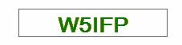

LBEW_47

  - Glass & Borderless form: This option shows only the Callsign and is a little tricky to maneuver. In order to see this option, you must have a call in the Logbook Entry window CALL field. To get to the menu options, you must right click on one of the callsign letters or numbers. To reposition the form, you must Left click and drag the box with the mouse pointer positioned on one of the letters or number since it does not have a visible perimeter border.

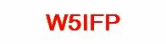

LBEW_48

If you lose track of the Floating Callsign form, you can find it in the usual way. From the Logger32 Main menu, select the View | Find lost windows menu items. When the Currently open dialog box is displayed, check the "Floating" check box and then the <Find> button. This will disable the Glass mode and position the window in the Upper Left hand corner of the screen.

You can also find the FLoating Callsign form (if it gets lost, or the rubber band in your mouse is loose) by typing the <Ctrl+F> key combination a second time in the Logbook Entry Window, CW Machine, or Sound Card Data Window. This will disable the GLASS option, making the form more visible.

